**ASSIGNMENT 1**

**AIM:**

Build a bridge rectifier circuit and

a. Find voltage at each node

b. Plot output waveform for given input

**CIRCUIT:**

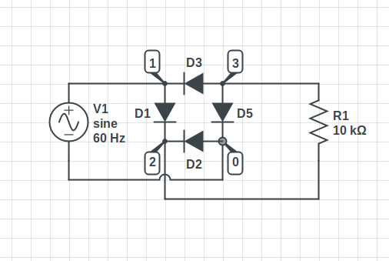

**OBSERVATIONS:**

A. Voltage at each node:

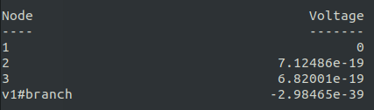

B. Output Waveform:

V(2,3) is the output voltage for V(1) input.

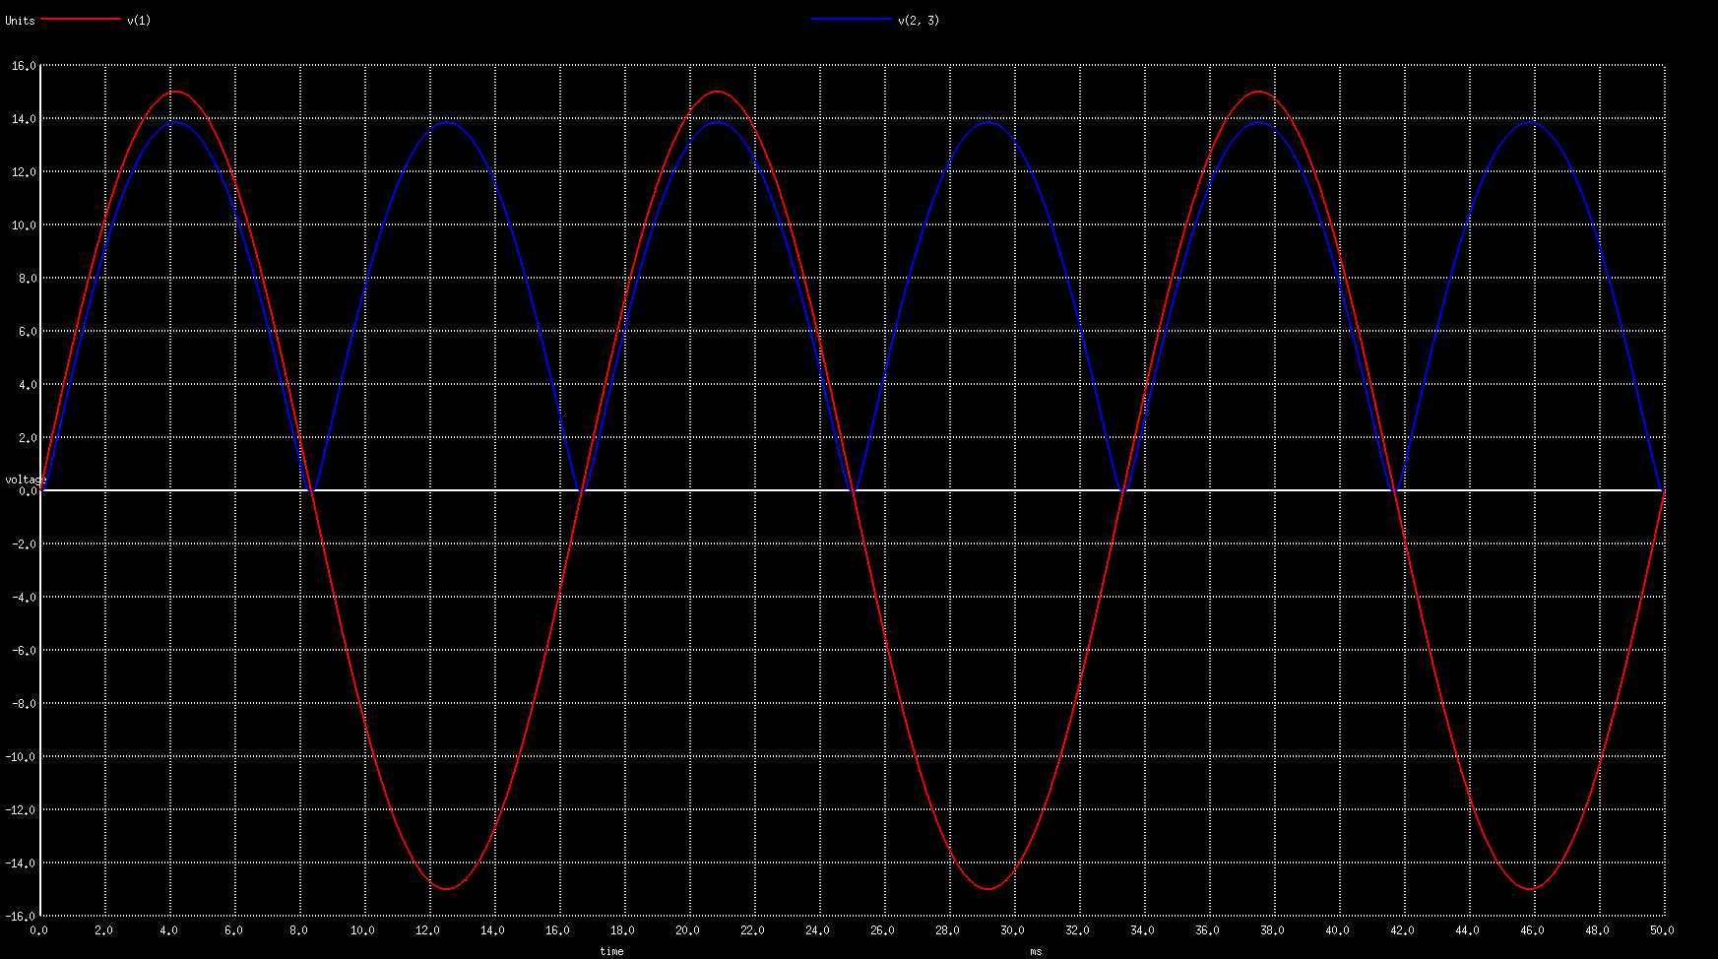

**CONCLUSION:**

Due to an additional bias voltage of diodes, the output doesn’t follow the input at all times.